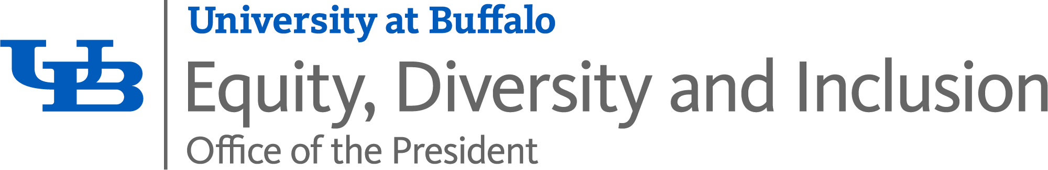

|  |
| --- |
| University at Buffalo |
| **Mandatory: 2024 SUNY Title VI Training Instructions** |
| A how to guide to complete your training |

Table of Contents

**2024 Title VI Mandatory New York State Training Instructions** 1

**Accessing the Course** 1

**Discovering the Course** 3

**Continue with the Course** 5

**Alternative Formats and Accessibility Features:** 9

**Certificate of Completion** 18

**Completing Mandatory: Title VI Training on Mobile Phones or Tablets -- Accessing UB Learns from your portable device.** 26

**Android Mobile Phone or Tablet:** 26

**iPhone Mobile Phone or iPad:** 33

# **2024 Title VI Mandatory New York State Training Instructions**

Follow the instructions below to complete the online training course via [UB Learns](https://ublearns.buffalo.edu/)

UB Learns Website Link: [ublearns.buffalo.edu](https://ublearns.buffalo.edu/)

*Important note: This course will **not** work when using the Internet Explorer (IE) internet browser.

Verify that your internet browser is compatible. To use UB Learns, use a computer that is connected to the Internet and the most up-to-date web browser. It is recommended that you use the most current version of:

Chrome Safari



Firefox Microsoft Edge

Brightspace technical support offers a list of certified and compatible browsers, listed by Operating System, for use with [UB Learns](https://ublearns.buffalo.edu/) [D2L Brightspace Compatible Browsers (UB Learns)](https://documentation.brightspace.com/EN/brightspace/requirements/all/browser_support.htm).

**Accessing the Course**

1. Go to [UB Learns](https://ublearns.buffalo.edu/d2l/login), and select “[Log in to Brightspace](https://ublearns.buffalo.edu/d2l/login)”.
   1. Enter your [UBIT Name](https://www.buffalo.edu/search/you) and [Password](http://www.buffalo.edu/ubit/service-guides/accounts/your-ubitname-account/managing-your-ubitname-and-password/change-password.html), Click **Login**.  
        
      To look up your UBIT Name, please go to: <https://www.buffalo.edu/search/you>
2. You may be prompted to verify your identity via [UB DUO](https://www.buffalo.edu/ubit/duo).
3. Begin at ‘**Select a Course**’, to the right of the **UB: Learns** icon  
     
     
     
     
     
     
     
     
     
     
     
     
     
     
     
   From your list, **Select** Mandatory: 2024 SUNY Training Course ADM_PRE_20240126_DIVERISTY  
     
     
     
   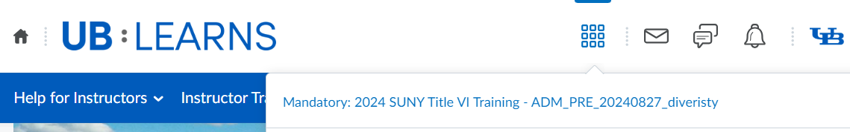  
     
     
     
     
     
     
     
   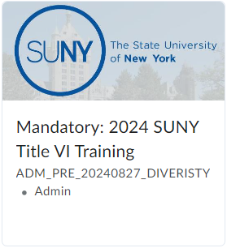  
   You may also access the course in your **‘My Courses’**   
   Widget once you have accessed the course once.   
     
   **Select** the Mandatory: 2024 SUNY Title VI Training  
     
   Course in your ‘**My Course**’ widget.  
     
     
     
     
     
     
     
     
   This will navigate you to the beginning of the course.

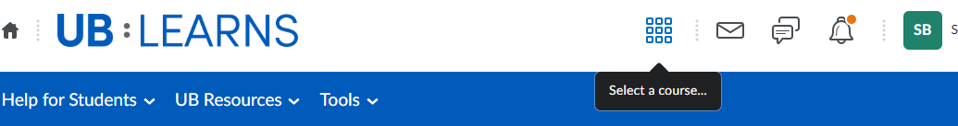

**Discovering the Course**

If you **do not** see the Mandatory: 2024 SUNY Title VI Training Course in your **‘Select a Course**’ pulldown, you will need to:

* **Discover** the course
* Self-Enroll in the course

1. From the UB Learns homepage, select **Tools**

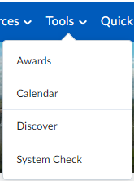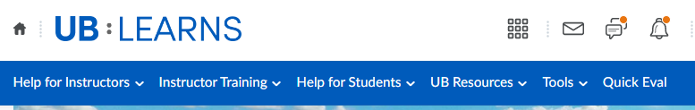

1. Select **Discover**

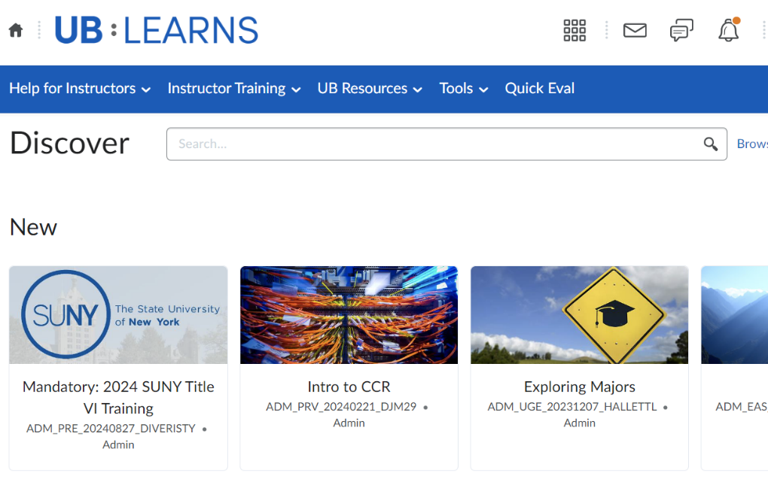

1. **Select**   
     
     
     
   Mandatory: 2024 SUNY Title VI  
     
   Training Course:
2. Select **Enroll in Course**

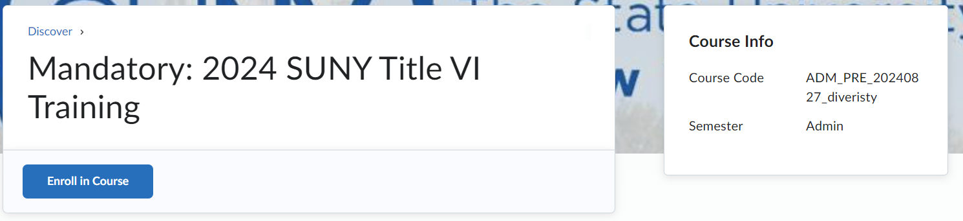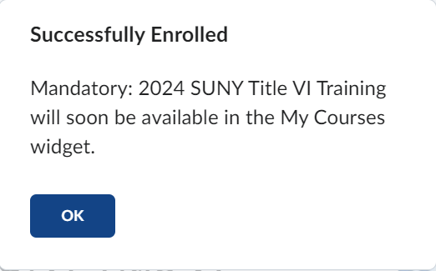

1. Select **OK** for Successful Enrollment:
2. Select **Open Course**

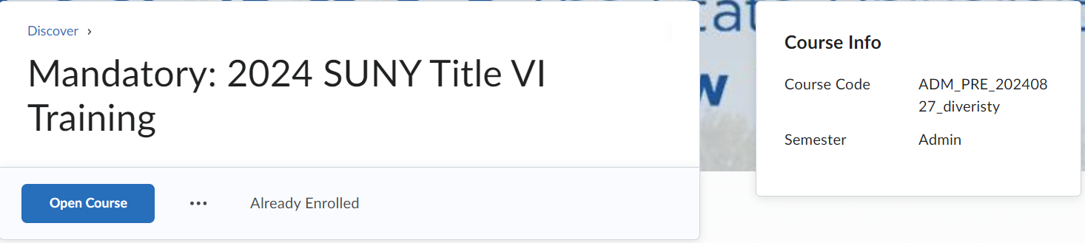

**Continue with the Course**

1. The Visual Table of Contents Widgets guides you through the course and additional resources available to you outside of the course content. For additional information regarding each Widget:  
     
     
     
   **Select** the **i** on each widget to ‘flip’ the Widget  
    and gain details on the Widget.  
     
     
     
     
     
     
   The additional Information for each Widget will display:  
     
     
   To flip back to the original view:  
     
   **Select** the Back Arrow in the upper left corner of the tile.

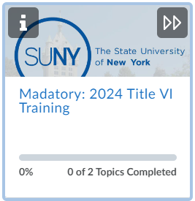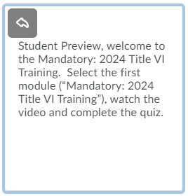

1. **Select** the **Mandatory: 2024 SUNY Title VI Training**

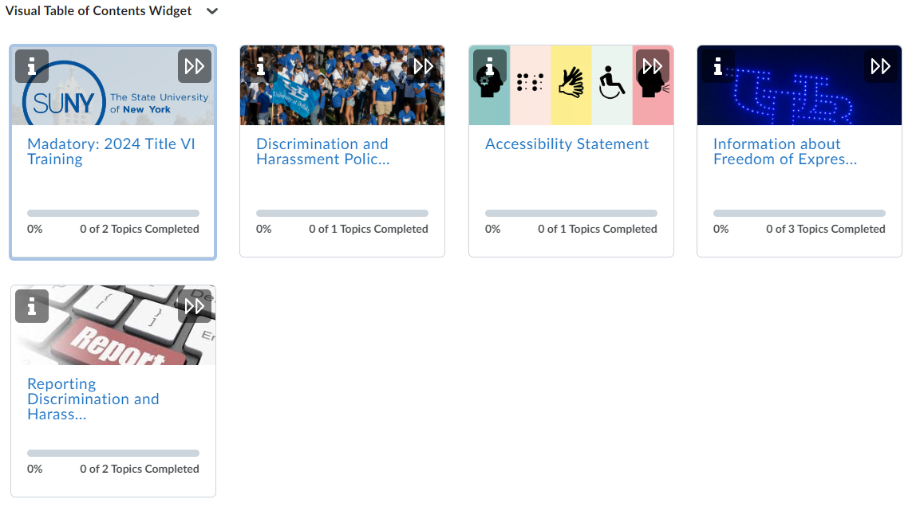

The course requires you to **watch** a video, **complete** a short quiz.

1. **Select** Watch the SUNY Title VI of the Civil Rights Act of 1964: Training Video for All Employees.

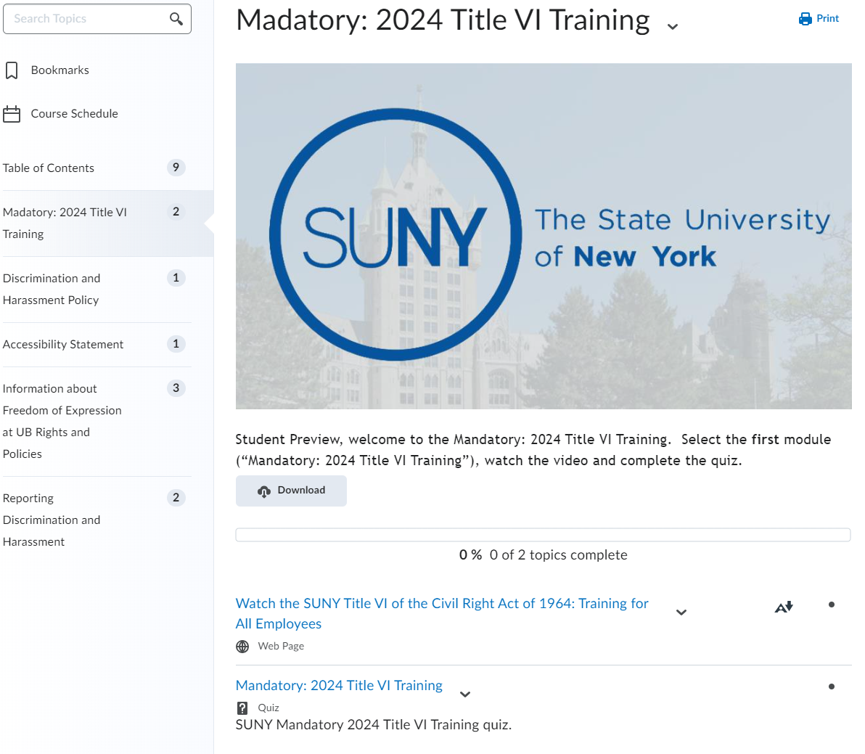

**Quiz: link will appear after watching the video**

**Video**

1. **Play** the **SUNY Title VI of the Civil Rights Act of 1964: Training for All Employees Video**  
     
   Start the training by **selecting** the play button in the middle of the screen.  
     
   You may choose to watch the video by downloading the video, opening the video in a new window or by making the video full sized.  
     
     
     
     
     
     
     
     
     
     
     
     
     
     
     
     
     
     
   [**Panopto**](http://www.buffalo.edu/ubit/service-guides/teaching-technology/teaching-services-for-faculty/panopto.html) is the video platform that was used to create the training video. The software requires your internet browser to accept third-party cookies. The Safari internet browser in particular may require you to change your settings in order to view this type of video file.  
     
   If you are using an Apple device (i.e., MacBook, iMac, iPad or iPhone) and the Safari browser, please review the following information regarding Panopto and the Safari internet browser:  
     
   [How to enable support for Third-Party browsers](https://support.panopto.com/s/article/How-to-Enable-Third-Party-Cookies-in-Supported-Browsers#hTargetInstance4)

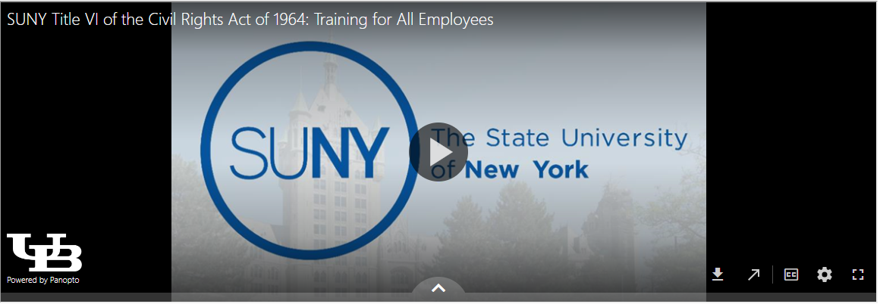

**Speed of Speaking**

**Download**

**Open New**

**Window**

**Toggle Captions**

**Full-Sized Video Window**

**Alternative Formats and Accessibility Features:  
  
To access Alternative Formats  
  
Select** the Alternative Formats link below the video.

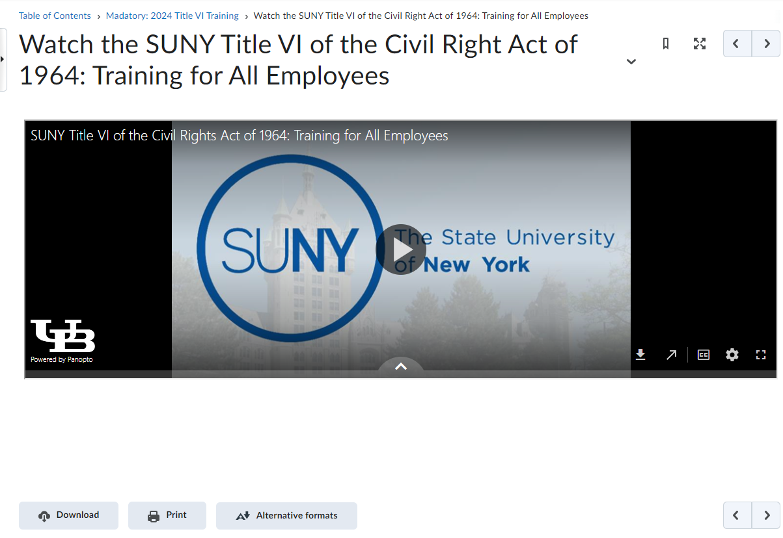

**Alternative Formats for the training video**

This will bring up the options to select multiple formats to review the training material.  
  
  
  
  
  
  
  
  
  
  
  
  
  
  
  
  
  
  
  
  
  
  
  
  
  
  
  
  
**Select** the desired format and select Download.  
  
  
**Begin the Quiz:**

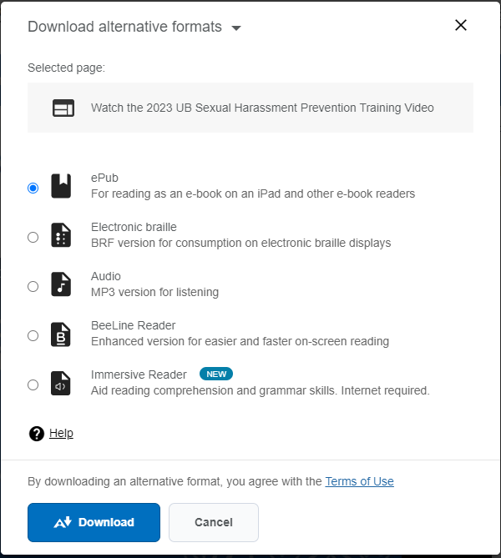

1. Post Training Quiz:  
   1. A screenshot of a computer

      Description automatically generatedNavigation Option I:  
        
      To begin the Quiz, **Select** the right arrow button above the video:

**Select Right Arrow**

The next page displays:

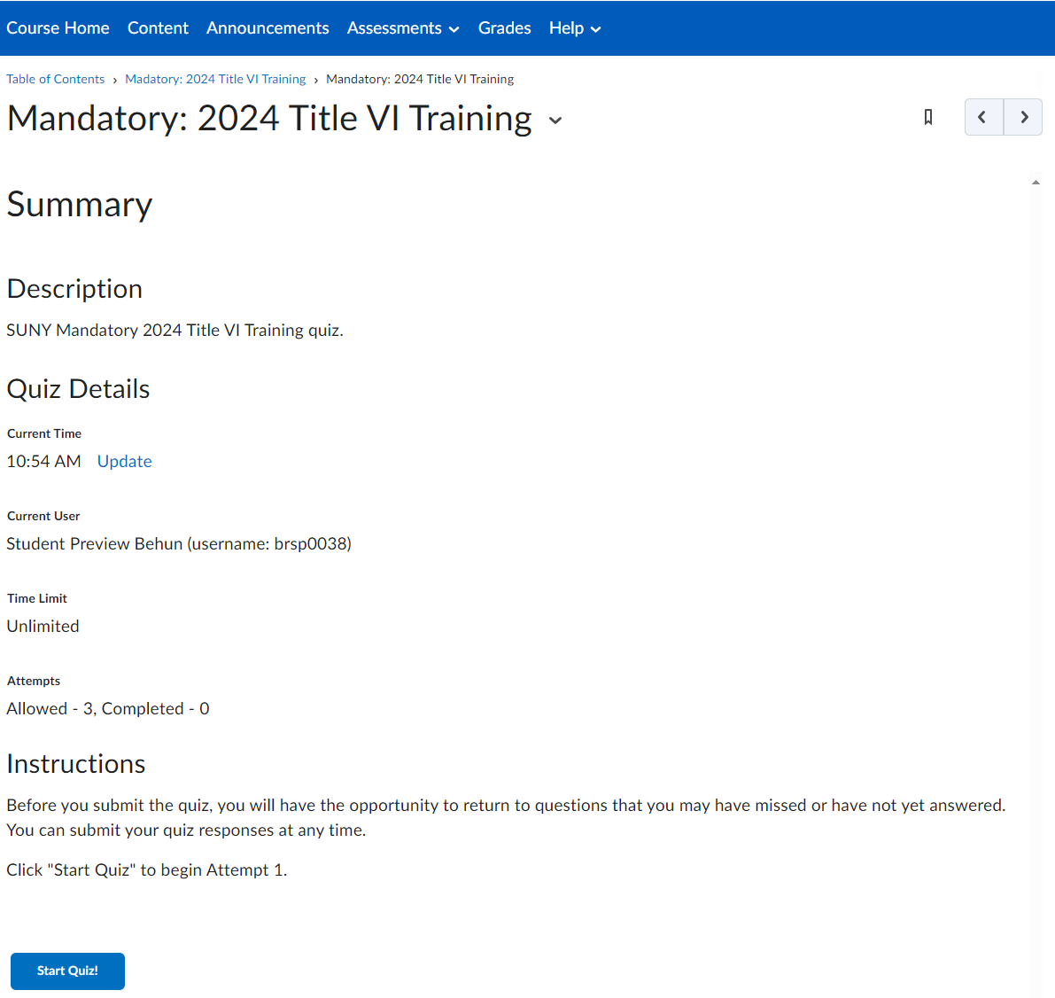

**Select Start Quiz!**

* 1. A screenshot of a computer

     Description automatically generatedNavigation Option II:  
       
     Navigate to the **2024 Title VI Mandatory New York State Training**.   
       
     **Select** the navigation link **Mandatory: 2024 Title VI Training**, the breadcrumb navigation, below the horizontal navigation bar.  
       
       
       
       
       
       
       
       
       
       
     **Select** the **Complete the 2024 Post Training Quiz** link

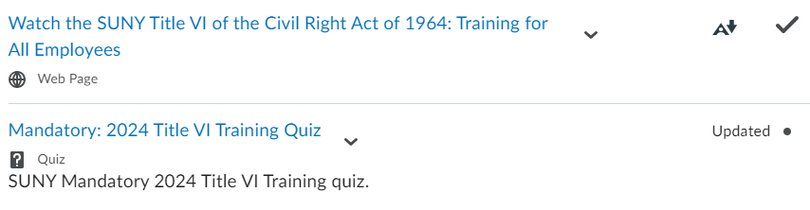

**Select link to begin quiz.**

**Breadcrumb Link**

1. **Complete** the Quiz

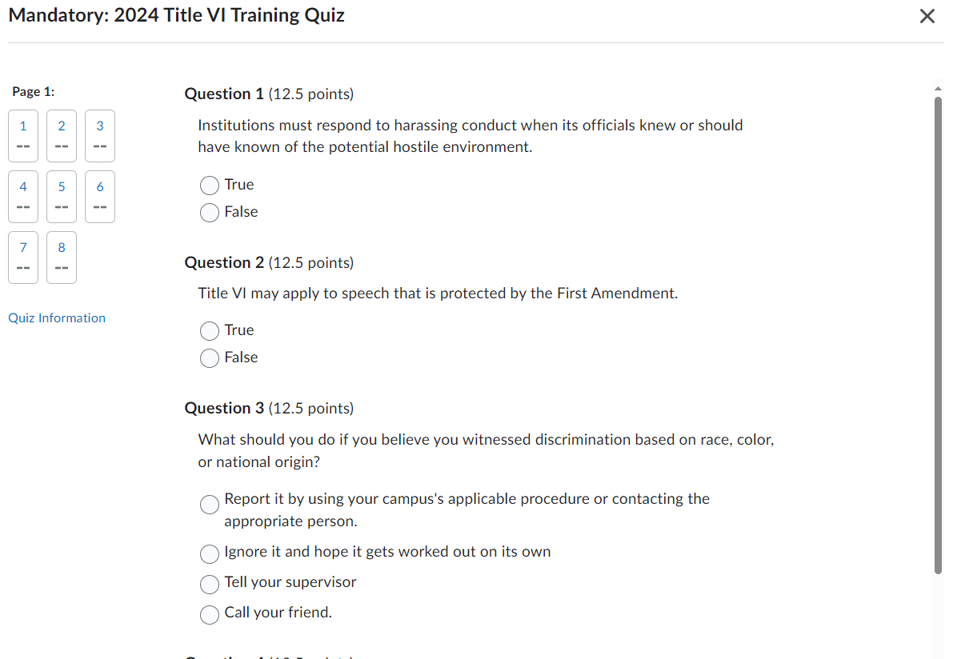

**Status of Quiz Completion**

* 1. Once you answer all the quiz questions, **select** **Submit Quiz**, and **select** **Submit Quiz** a second time, and the following page will appear:   
       
     A screenshot of a quiz

     Description automatically generated  
       
     **Scroll** to the bottom of the page and  
       
       
     **Select** **Done** and you will be taken to the next page.
  2. You will receive a Post Quiz Summary Page:  
       
       
     A screenshot of a computer

     Description automatically generated
  3. **Select** the Right Arrow

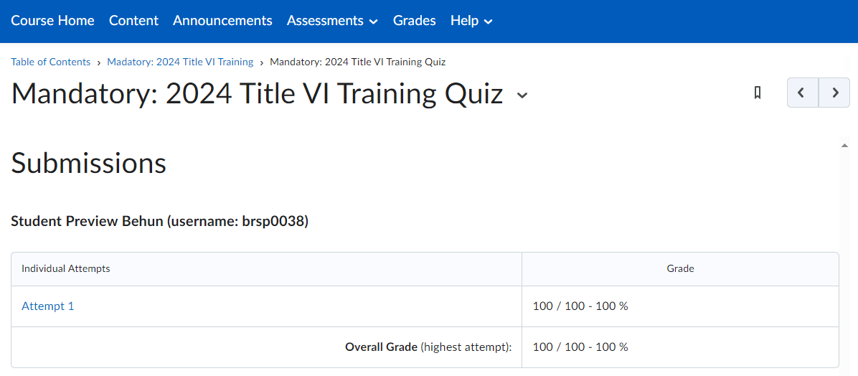

Your Name, (username: your UBIT Name)

* 1. You will be taken to the next Table of Contents component and the following pop-up will display if you completed the quiz with a passing grade and selected all the acknowledgements:

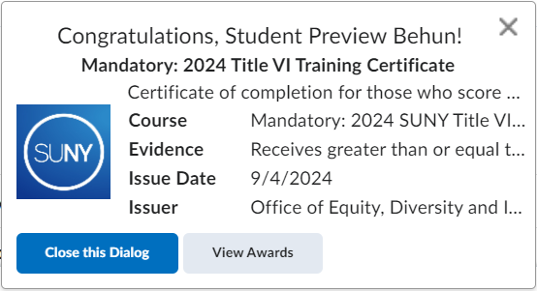

**Quiz Completion Pop-up**

**Certificate of Completion**

1. Viewing Your Awards/Certificate of Completion  
     
   **Select** ‘**View Awards’**  
     
     
     
     
     
     
     
     
     
     
     
     
     
   If you do not receive a pop-up listed above, you may access your certificate by the following:



**Select View Awards to create a Certificate!**

* 1. **Select** the **Messaging icon** to view the latest updates about the course:



* 1. **Select** the **Message** you would like to view:

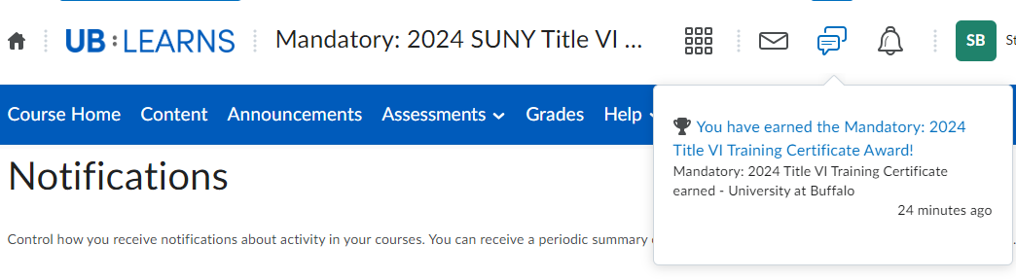

* 1. You will navigate to the **‘My Awards’** page:  
       
       
       
       
       
       
       
       
       
       
       
       
       
     **Select** the **Sexual Harassment link**

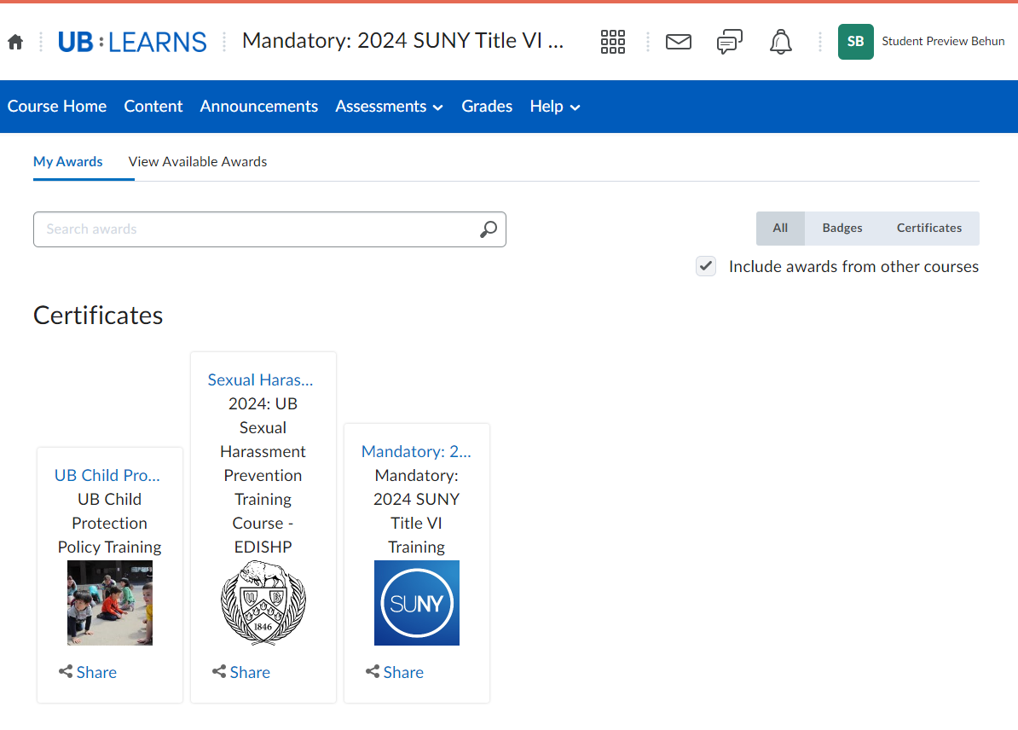

**Select Mandatory: 2024 SUNY Title VI Training Course Certificate**

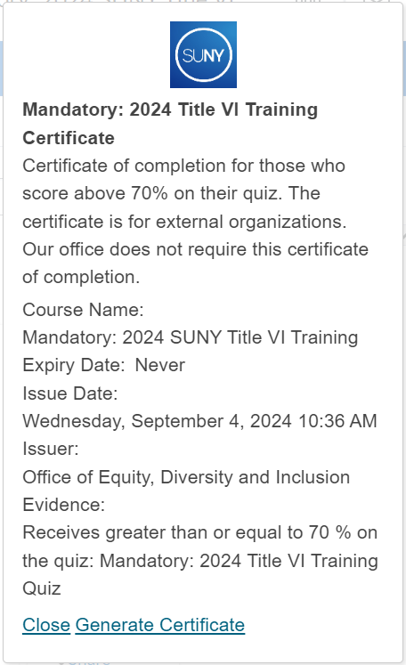

* 1. 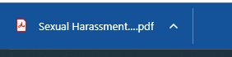The following pop-up will appear:  
       
       
       
       
       
       
       
       
       
       
       
       
       
       
     **Select** **‘Generate Certificate’** to create a   
     PDF Certificate of Completion  
       
       
       
       
       
       
     A PDF will Download to your device.  
       
       
       
       
     **Go To** your downloads to view the certificate.

If you do not receive a pop-up, or see a message  
in your message area, you may access your  
certificate by the following:

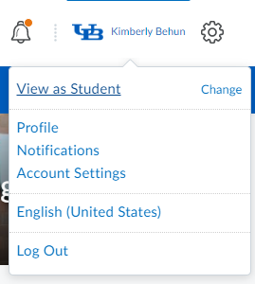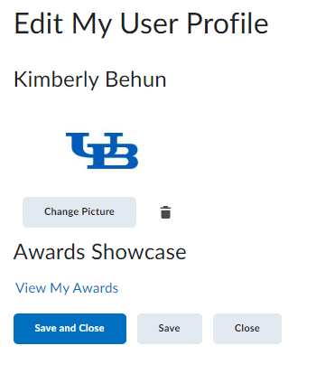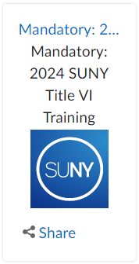

* 1. **Select** your Profile Name and select **Profile**:
  2. Select **View My Awards**:
  3. Select the **Mandatory: 2024 SUNY Title VI Training link**

The following pop-up will appear:  
  
  
  
**Select** **‘Generate Certificate’** to create a   
PDF Certificate of Completion  
  
  
  
  
  
  
  
  
  
  
  
  
  
  
  
  
  
  
  
  
  
  
  
A PDF will Download to your device.



* 1. A certificate of equality and inclusion

     Description automatically generatedTo View the Certificate, **Open** the PDF  
       
       
       
       
       
       
       
       
       
       
       
       
       
       
       
       
       
       
       
       
       
       
       
       
       
       
     **Please DO NOT** Email EDI with your certificate. We receive your completion information from UB Learns, and this is entered into our official records. Our training liaisons will have access to our official records.   
       
     Your certificate is for external organizations who may require your completion.

1. Course Completion Email  
     
   UB Learns Brightspace will email a completion notification to you once you have completed the video and the quiz.  
     
   A screenshot of a computer

   Description automatically generated  
     
     
     
     
     
   **Please DO NOT** Email EDI with your Email Notification. We receive your completion information from UB Learns, and this is entered into our official records. Our training liaisons will have access to our official records.
2. **Logout** of UB Learns Brightspace  
   1. **Selec**t **‘your name’** in the upper right corner of your UB Learns window.  
        
      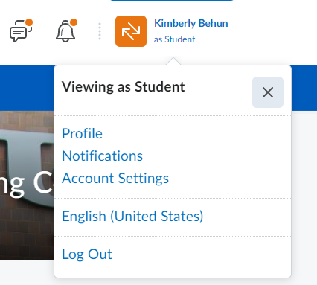

Your Name

* 1. **Select** **‘Log Out’**
  2. **Close** all internet tabs.

## **Completing Mandatory: Title VI Training on Mobile Phones or Tablets -- Accessing UB Learns from your portable device.**

UB Learns is available within the new Learning Management System via the app named **Brightspace Pulse**. Brightspace Pulse is available through [Google Play](https://play.google.com/store/apps/details?id=com.d2l.brightspace.student.android&hl=en_US&gl=US)® or the [Apple App Store](https://apps.apple.com/us/app/brightspace-pulse/id1001688546)®. Requirements for mobile phones or tablets are available on the [D2L Brightspace Pulse website](https://documentation.brightspace.com/EN/pulse/-/all/platform_requirements.htm?tocpath=Administrators%7CBrightspace%20Pulse%7C_____1).

### **Android Mobile Phone or Tablet:**

1. **Go to** the Google Play™ App on your device



1. **Search** for the **Brightspace Pulse** app

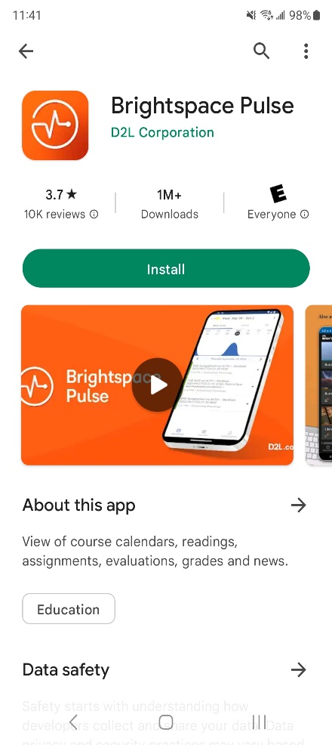

1. **Select** the Pulse App for Brightspace  
   and select **Install**:

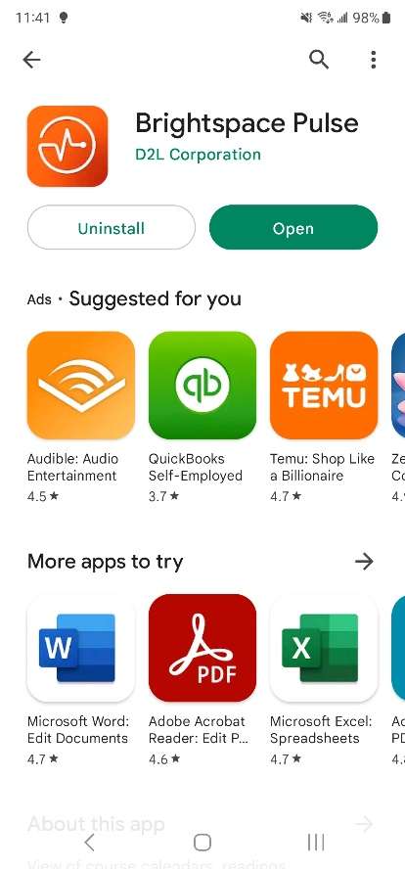

1. Brightspace Pulse App will install,  
   select **Open** when complete:
2. There are 3 screens to view the Brightspace APP:

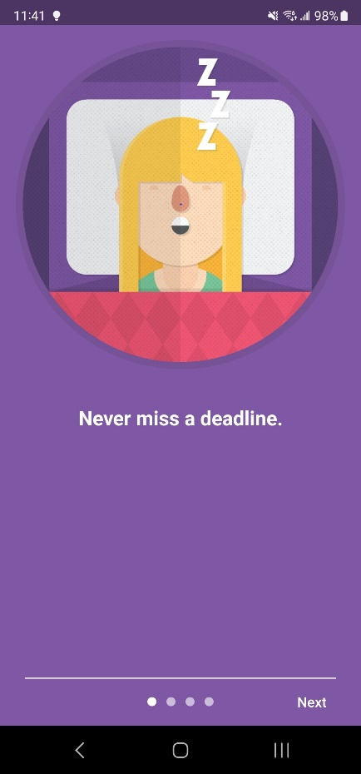

**Screen 1**

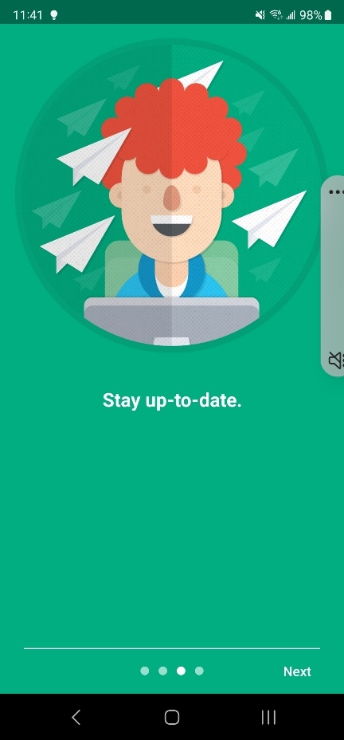

**Screen 3**

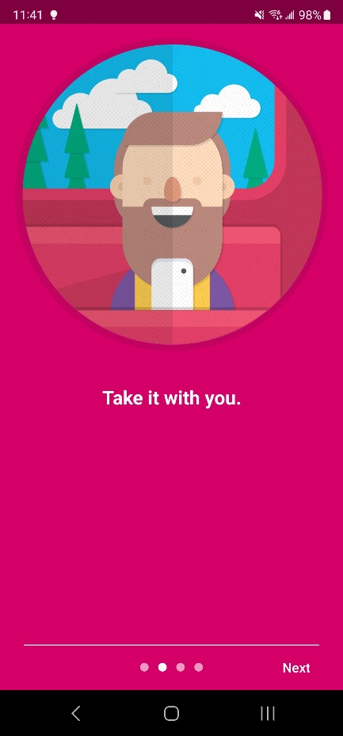

**Screen 2**

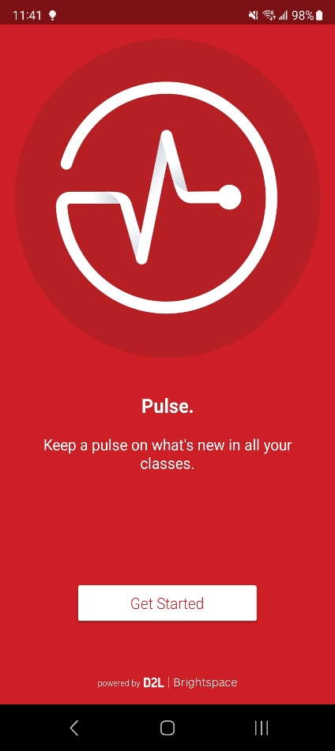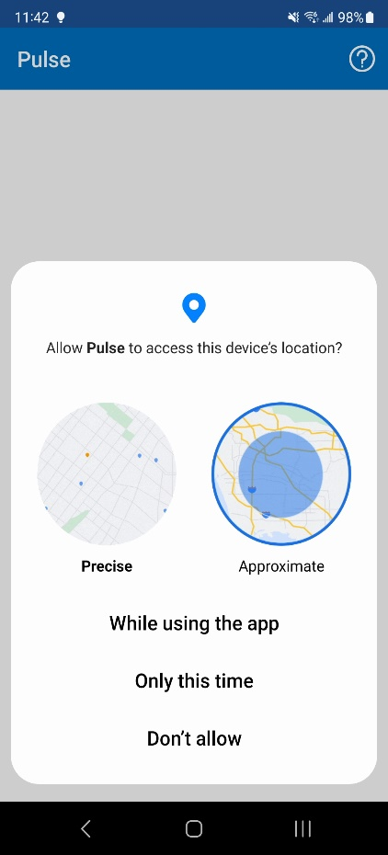

1. On the last screen select **Get Started**:
2. Select **While using the app**   
   to assist in finding the course:

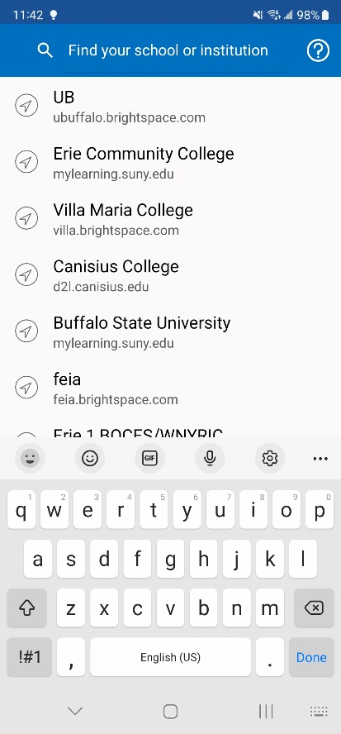

1. **Search** for **UB**:

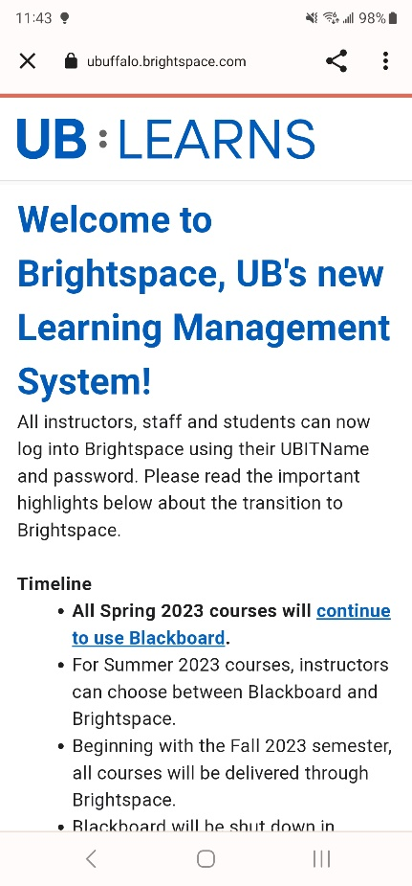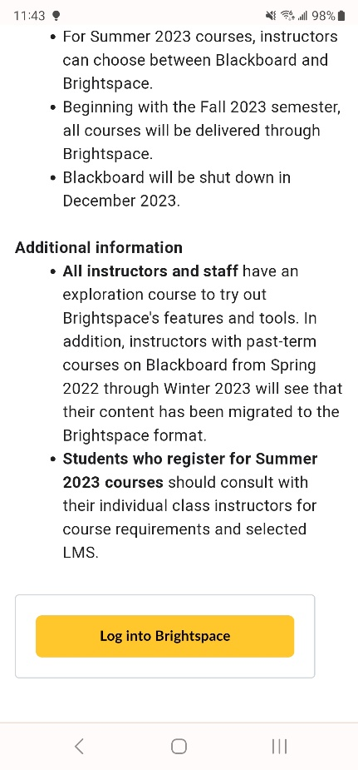

1. Welcome to UB Learns:  
     
     
     
   Scroll down to **Select**  
     
     
     
   **Log into Brightspace**

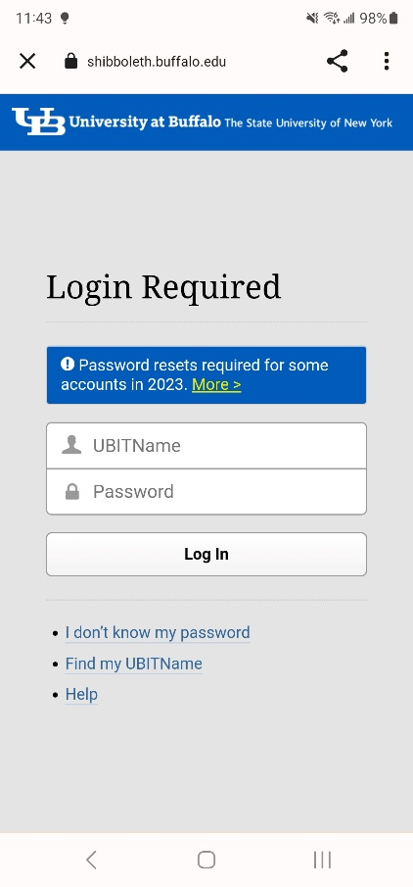

1. Enter your **UBIT Name**,  
     
   Your **UBIT Password**  
     
   Select **Log In**  
     
     
     
     
     
     
     
     
     
     
   You may be prompted for your [UB Duo Two-Step Verification](https://www.buffalo.edu/ubit/duo)

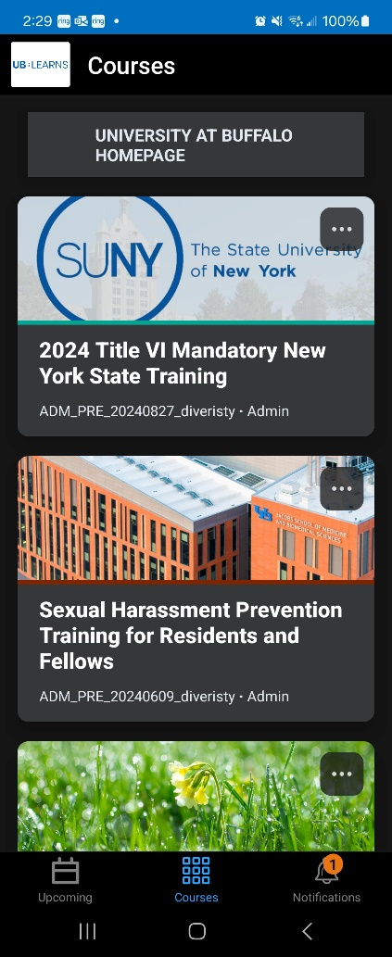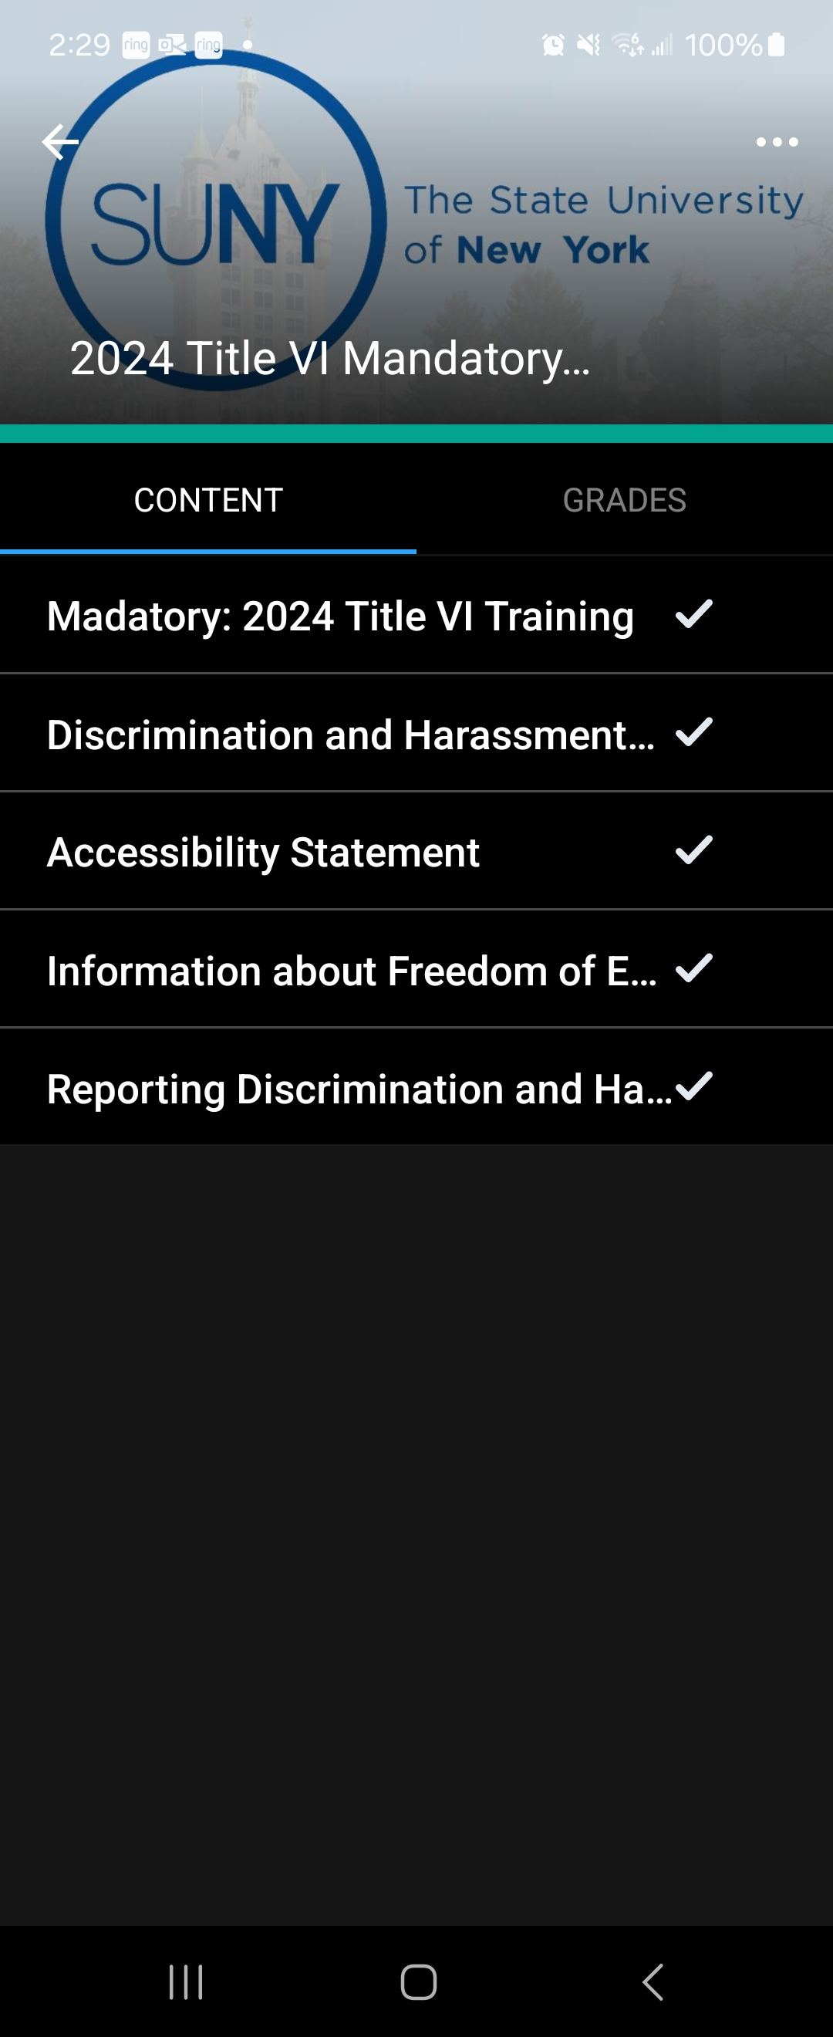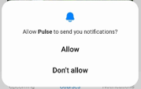

1. **Select** either **Allow** or **Don’t allow** for   
     
     
     
     
     
     
     
   Notifications from the Brightspace Pulse App:  
     
   This is a personal choice.
2. **Begin** the course:  
     
   1. **Select** the Mandatory: 2024 Title VI Training Course:  
      1. **Watch** the Video
      2. **Complete** the Quiz
   2. You have **completed** the course on your Android  
      device.

### **iPhone Mobile Phone or iPad:**

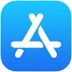

1. **Go to** the **Apple App Store** ® on your device
2. **Search** for the **Brightspace Pulse** app
3. **Select** the **Pulse App** for Brightspace  
   and select **Install**:
4. Brightspace Pulse App will install,  
   select **Open** when complete:



1. There are 3 screens to view the Brightspace APP:



**Screen 1**



**Screen 3**



**Screen 2**

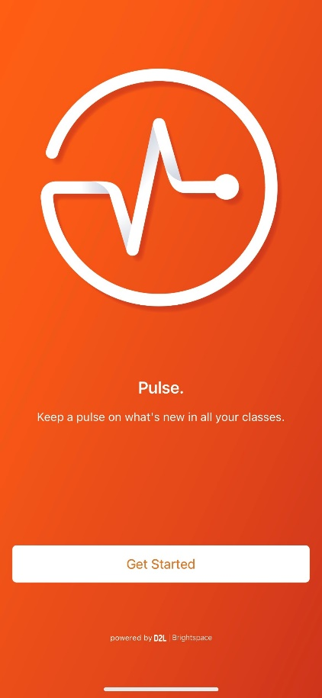

1. On the last screen **Select** **Get Started**:
2. **Select** **While using the app** to assist in finding the course:

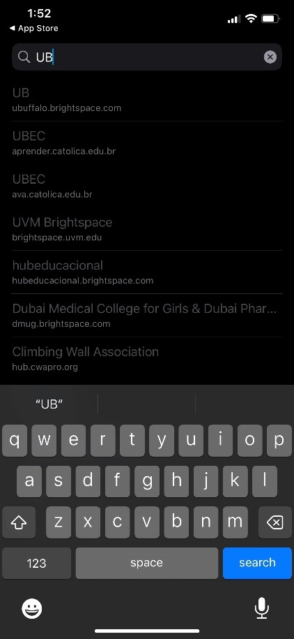

1. Search for **UB**:

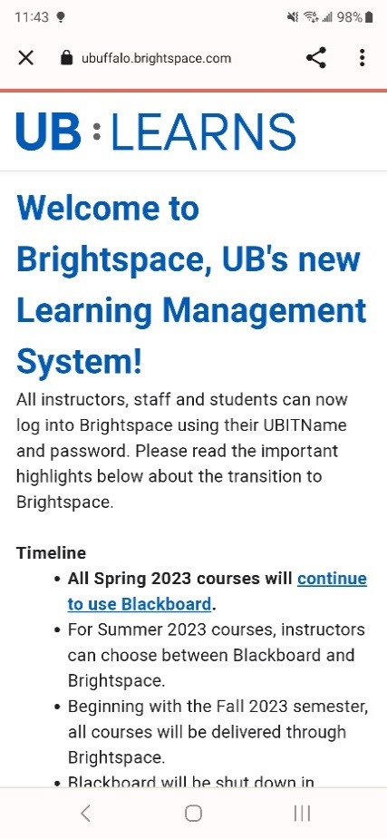

1. Welcome to UB Learns:  
     
     
     
     
     
     
     
     
     
     
     
     
     
     
     
     
   Scroll down to **Select**  
     
     
     
     
     
     
     
     
     
   **Log into Brightspace**



1. **Enter** your **UBIT Name**,  
     
   Your **UBIT Password**  
     
   **Select** **Log In**  
     
     
     
     
     
     
     
     
     
     
     
   You may be prompted for your [UB Duo Two-Step Verification](https://www.buffalo.edu/ubit/duo)

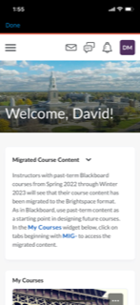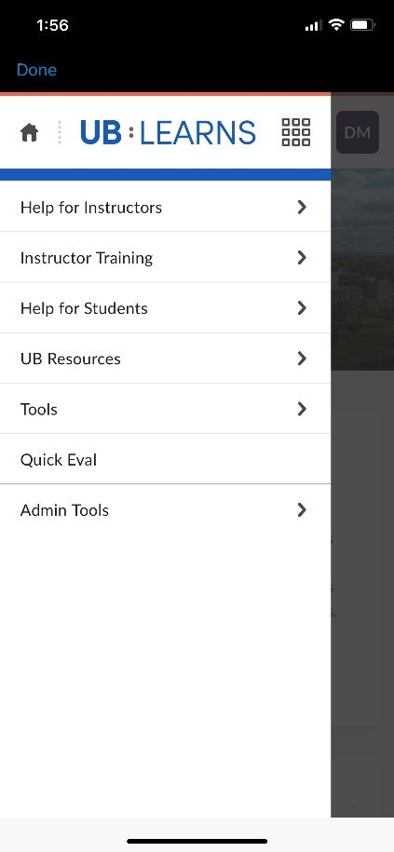

1. If the course does not automatically display, you will   
   need to **Discover** the course.  
     
   1. From the UB Learns home screen   
        
      **Select** the **three lines**
   2. **Select** **Tools**:

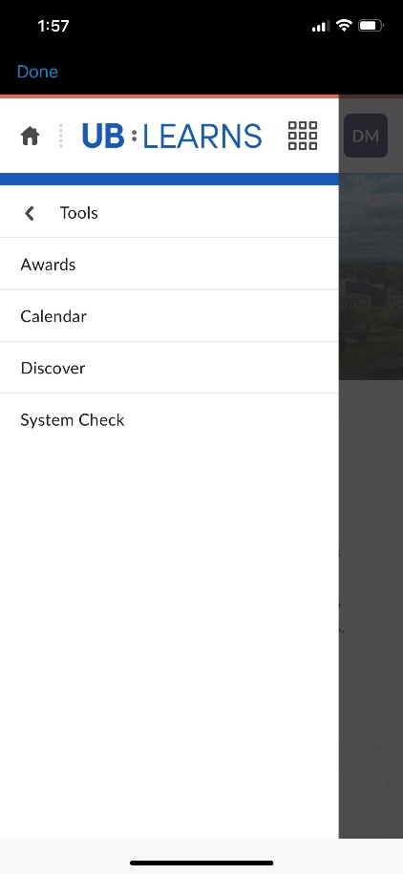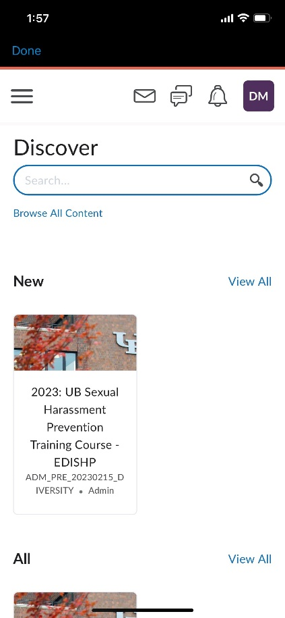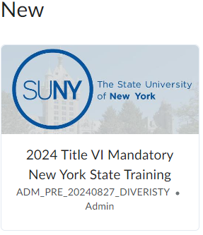

* 1. **Select** **Discover**:
  2. In Discover, the Mandatory: Title VI Training   
       
     Course will display.  
       
       
     **Select** the Mandatory: 2024 Title VI  
     Training Course.

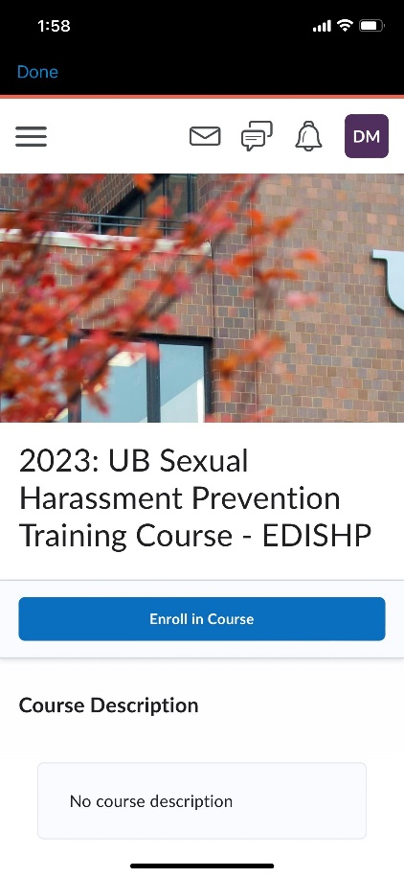

* 1. A screenshot of a phone

     Description automatically generated**Select** **Enroll in Course**

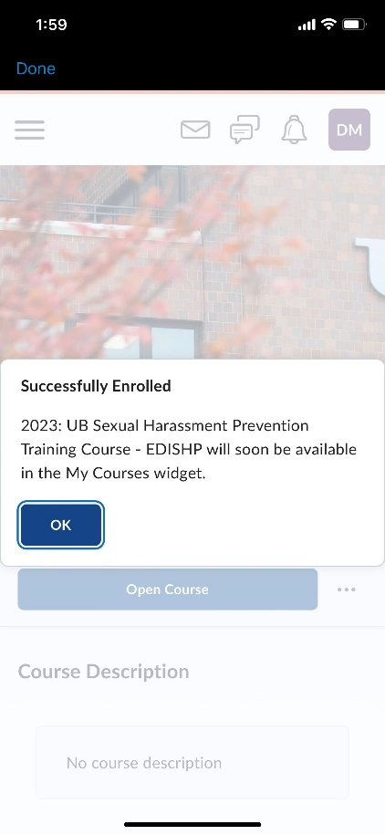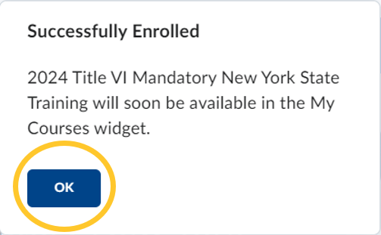

* 1. **Select** **OK** on the Successfully   
     Enrolled window

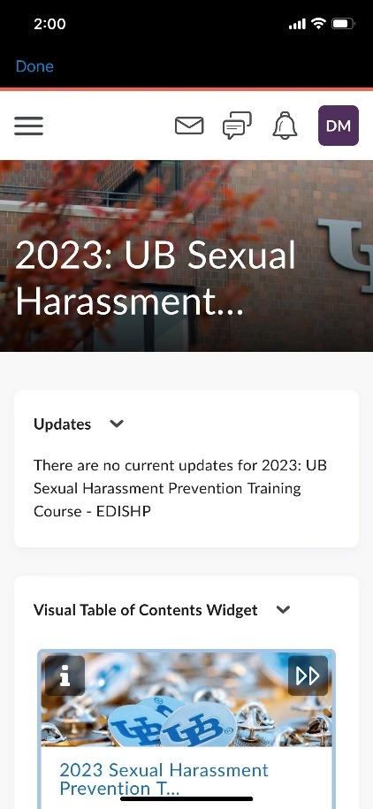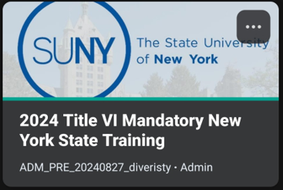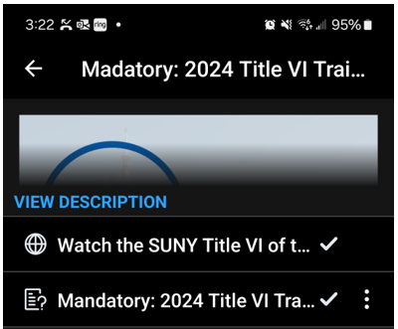

1. **Begin** the course:  
   1. **Select** the Mandatory: 2024 Title VI  
      Training Course:  
      1. **Watch** the video
      2. **Complete** the quiz
2. You have **completed** the course on your Apple Device.